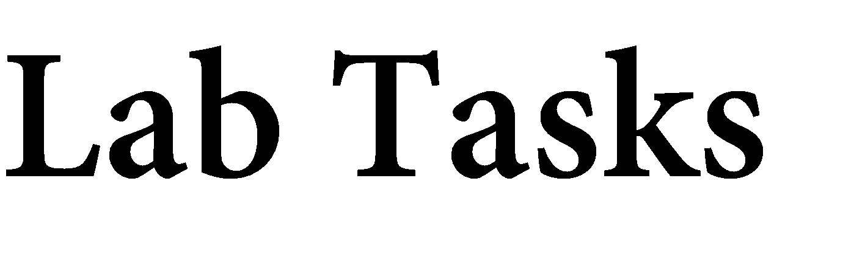

Name: Muhammad Faisal
Roll no: 2022F-BCS-152

Section: C
Instructor Name: Miss Sobia Asher
Course: Computer Networks Lab (CS – 317L)
Program: (BS) - Computer Science

Lab #01

Task 1:
Network | Networking
- A network is a set of computing devices connected to share information and resources.  - It is a collection of devices that communicate with each other when connected. | - Networking is the process of creating and managing a computer network, involving hardware, protocols, and software.  - It includes activities like setup, maintenance, and support for both wired and wireless technologies.

Task 2: Components of data communication model?
A data communication model, also called a communication model or system, includes essential components for data transfer between a sender and receiver:

1. Sender: Initiates the data transmission.
2. Receiver: Accepts the transmitted data.
3. Message: The data being sent.
4. Transmission Medium: The path through which data travels.
5. Protocol: Rules governing data format and timing.
6. Encoder and Decoder: Convert data for transmission and reception.
7. Channel: The specific path used within the transmission medium.
8. Noise: Interference that may degrade data quality.
9. Feedback: Provides information on data reception and quality, helping with error detection and correction.

Task 3: Does analogue conversation take place in source as transmitter?
Analog conversation can occur both at the source and during transmission. At the source, analog conversation happens when the original data is in an analog form, such as voice or music. During transmission, this data might be converted into analog signals; however, in many modern systems, it often remains in digital form to ensure more efficient and high-quality communication.

Task 4: Give an example of data communication model?
An example of a data communication model is the transfer of information from one device or system to another, such as when an email is sent from a computer to a mobile phone. In this process, the information is first encoded into a digital format and then transmitted through a network, like the internet, to reach the intended recipient. Upon arrival, the recipient’s device decodes the information, allowing the user to read or interact with the content.

Task 5: What is Peer-to-Peer network?
A Peer-to-Peer (P2P) network is a type of computer network where all connected devices hold equal status, allowing them to communicate and share resources directly with one another. Unlike client-server networks, which rely on a central server to manage resources and respond to client requests, P2P networks enable each node to both provide and consume resources independently. This decentralized structure allows for resource sharing such as files, processing power, or services without a central server. P2P networks are commonly used for file sharing, distributed computing, and collaborative tasks. While they offer benefits like resilience and direct access to resources, they can also pose challenges in security and network management.

Task 6: Build LAN & WAN environment using Packet Tracer?
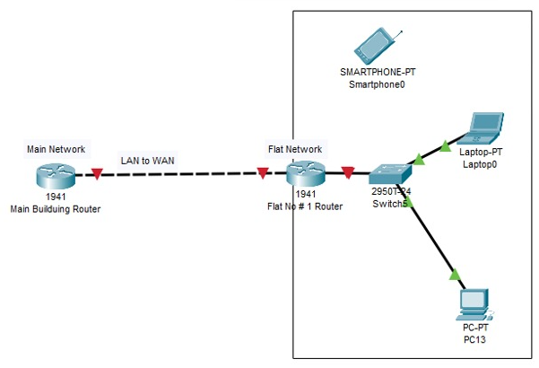

Lab #02

Task 1: What is difference between partial and full mesh topology?
Partial mesh and full mesh are both types of network topologies used in networking to determine how devices are interconnected. Here are the key differences between the two:

Partial Mesh Topology:
- Only some devices have direct connections to others.
- Reduces complexity and cost.
- Used when not every device needs direct communication with all others.

Full Mesh Topology:
- Every device has a direct connection to every other device.
- Provides high redundancy and fault tolerance.
- Common in critical communication environments where direct connections are essential.

Task 2: Design Bus and Star Topology environment using Packet Tracer?

Bus Topology

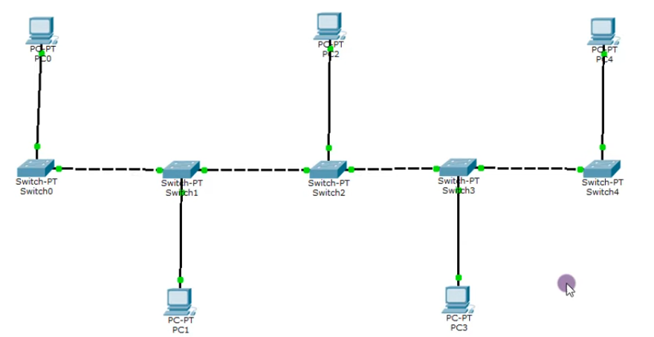

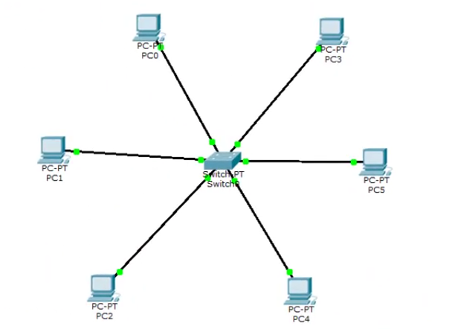
Star Topology

Activity #01

Describe switches and network topologies, along with their advantages and disadvantages.
Switch:
A switch is a networking device that connects multiple devices within a local area network (LAN). It operates at the data link layer (Layer 2) of the OSI model, forwarding data packets between devices based on their MAC addresses. Switches facilitate communication within the network, allowing devices to share resources efficiently.

Advantages of Switches:
- Improved Performance: Switches reduce network congestion by creating separate collision domains for each connected device, leading to higher throughput.
- Enhanced Security: They can isolate traffic between devices, improving security and reducing the risk of data interception.
- Flexibility: Switches allow for easy network expansion by connecting additional devices without significant reconfiguration.
- Support for VLANs: Many switches support Virtual Local Area Networks (VLANs), enabling segmentation of network traffic for better management and security.

Disadvantages of Switches:
- Cost: Managed switches tend to be more expensive than unmanaged switches due to advanced features and capabilities.
- Complexity: Configuration and management of managed switches can be complex, requiring network administration skills.
- Limited Range: Switches operate within a local area network and cannot be used to connect devices over long distances without additional devices (e.g., routers).

Topology:
Topology refers to the arrangement of different elements (links, nodes, etc.) in a computer network. It defines how devices are interconnected and how data flows between them. Common network topologies include star, ring, bus, tree, and mesh.

Advantages of Different Topologies:

Star Topology:
- Easy to install and manage.
- Failure of one device does not affect the rest of the network.

Ring Topology:
- Simple to install and troubleshoot.
- Predictable data transmission times due to a unidirectional data flow.

Bus Topology:
- Cost-effective for small networks.
- Easy to implement and extend.

Mesh Topology:
- High redundancy and fault tolerance.
- Direct connections ensure reliable data transmission.

Disadvantages of Different Topologies:

Star Topology:
- Relies heavily on the central hub; if it fails, the entire network goes down.
- More cabling required compared to bus topology.

Ring Topology:
- A failure in any single device can disrupt the entire network.
- Difficult to troubleshoot due to its circular nature.

Bus Topology:
- Limited cable length can affect performance.
- Difficult to troubleshoot and isolate faults.

Mesh Topology:
- High installation and maintenance costs due to extensive cabling.
- Complex to configure and manage as the number of devices increases.

Lab #03

Q.1) What is the significance of twisting in twisted pair copper wires?
Twisting reduces electromagnetic interference (EMI) and crosstalk between adjacent wires. By twisting, each pair alternates in exposure to external interference, which helps cancel out noise, leading to better signal quality over longer distances.

Q.2) What is the difference between unshielded and shielded twisted pair wires?
- UTP: Lacks additional shielding, making it lighter, more flexible, and less expensive. However, it's more susceptible to interference, so it is mainly used in less noisy environments.
- STP: Has an additional metal shielding around the twisted pairs, which reduces interference. It’s used in environments with high EMI, like factories or data centers.

Q.3) What is the difference between guided and unguided medium?
- Guided Medium: Uses physical paths (like cables) to transmit data, including twisted pairs, coaxial cables, and fiber optics. It offers high data transmission rates and lower interference.
- Unguided Medium: Uses electromagnetic waves in open space (like air) to transmit data, e.g., radio, microwave, and infrared. It enables wireless communication but is more prone to interference and has variable data rates.

Q.4) What are the application of fiber optics, twisted pair and coaxial cables?
- Fiber Optics: High-speed, long-distance communication for internet backbones, data centers, and high-definition broadcasting.
- Twisted Pair: Commonly used in LANs, telecommunication networks, and Ethernet connections in homes and offices.
- Coaxial Cable: Used for cable television, broadband internet, and older Ethernet networks.

Q.5) What is the position of transmission media in OSI model?
Transmission media is part of the Physical Layer (Layer 1) of the OSI model, responsible for transmitting raw bits over a physical link.

Q.6) Just name the components of optical fiber cables?
- Core
- Cladding
- Coating/Buffer
- Strengthening Members
- Outer Jacket

Q.7) What are the usage of straight and cross over cables?
- Straight-through Cable: Used to connect different devices, like a computer to a switch or router.
- Crossover Cable: Used to connect similar devices, such as two computers or two switches directly.

Lab #04

Exercises:

- Based on the topology, how many subnets are needed?
This depends on the topology and the number of networks required for each segment (e.g., LANs, DMZ, server network, etc.). The number of subnets directly impacts how many bits to borrow from the host portion.

- Why we divide the range of ip address from 0 to 255 in classes?
Originally, IP addresses were divided into classes (A, B, C, D, E) to simplify network management by providing a fixed number of network and host bits for each class:
- Class A: Large organizations, more hosts per network.
- Class B: Medium-sized networks.
- Class C: Smaller networks with fewer hosts.
This division enabled efficient address allocation, though Classless Inter-Domain Routing (CIDR) later replaced class-based addressing to better utilize the IP address space.

- What is CIDR or slash notation. Give the maximum and minimum range of each class.
- CIDR (Classless Inter-Domain Routing), also known as slash notation, allows flexible allocation of IP addresses by specifying the subnet mask length with a slash. For example, /24 means 24 bits for the network portion and the remaining for the host.
- Maximum and Minimum Range of Each Class:
- Class A: 1.0.0.0 to 127.255.255.255 (/8 to /31)
- Class B: 128.0.0.0 to 191.255.255.255 (/16 to /31)
- Class C: 192.0.0.0 to 223.255.255.255 (/24 to /31)
- Class D: 224.0.0.0 to 239.255.255.255 (Multicast)
- Class E: 240.0.0.0 to 255.255.255.255 (Experimental)
- Find the subnet mask only of the following ip address:

- 192.168.60.20/28
/28 means 28 bits for the network, so the subnet mask is 255.255.255.240.

- 202.50.6.7/26
/26 means 26 bits for the network, so the subnet mask is 255.255.255.192.

- 215.54.7.80/29
/29 means 29 bits for the network, so the subnet mask is 255.255.255.248.

Lab #05 (a)

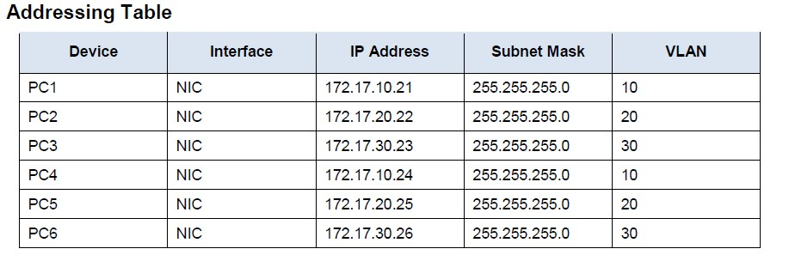

Lab Tasks
- On S1, issue the command that displays all VLANs configured
- Create and name VLANs on S1.
- S1#(config)# vlan 10
- S1#(config-vlan)# name Faculty/Staff
- Create the remaining VLANS.
  - VLAN 20: Students
  - VLAN 30: Guest(Default)
  - VLAN 99: Management&Native
  - VLAN 150: VOICE
- Create the same VLANs on S2 and S3.
- Assign VLANs to the active ports on S2
- S2(config)# interface f0/11
- S2(config-if)# switchport mode access
- S2(config-if)# switchport access vlan 10
- Assign the remaining ports to the appropriate VLAN.
  - VLAN 20: FastEthernet 0/18
  - VLAN 30: FastEthernet 0/6
- S3 uses the same VLAN access port assignments as S2. Configure the interfaces as access ports and assign the VLANs as follows:
  - VLAN 10: FastEthernet 0/11
  - VLAN 20: FastEthernet 0/18
  - VLAN 30: FastEthernet 0/6
- Assign the VOICE VLAN to FastEthernet 0/11 on S3.
- S3(config)# interface f0/11
- S3(config-if)# mls qos trust cos
- S3(config-if)# switchport voice vlan 150
- Verify loss of connectivity. Try pinging between PC1 and PC4.
- S2# show vlan brief
  - Although the access ports are assigned to the appropriate VLANs, were the pings successful? Explain.

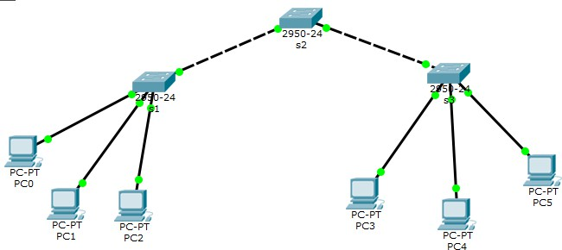

- s1
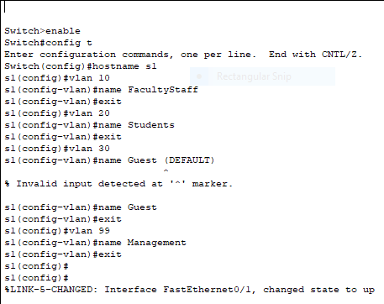

- s2
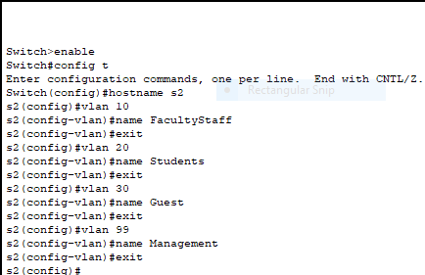

- s3
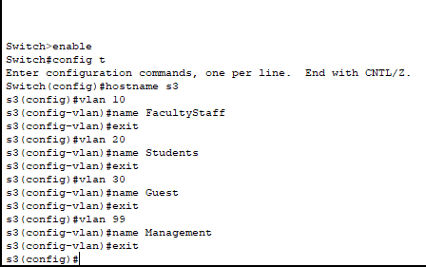

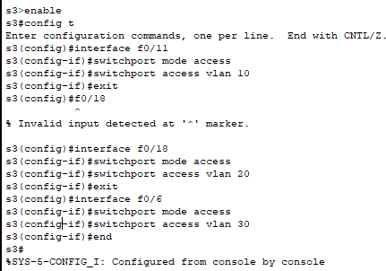
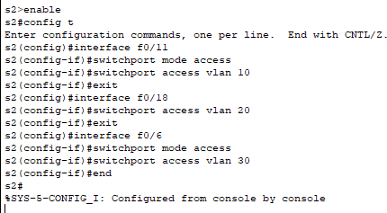

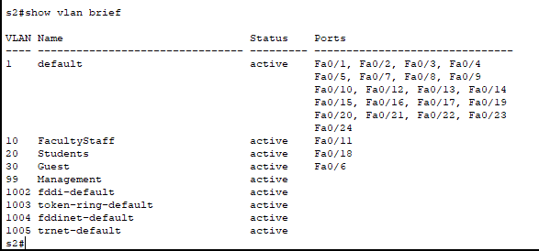

Although the access ports are assigned to the appropriate VLANs, were the pings successful? Explain.
The success of pings in a network where access ports are assigned to appropriate VLANs depends on several factors beyond just VLAN assignment:
- Inter-VLAN Routing: If devices are in different VLANs, they cannot communicate with each other unless inter-VLAN routing is configured. This typically requires a Layer 3 device like a router or a Layer 3 switch to route traffic between VLANs.
- IP Address Configuration: Devices must have proper IP addresses assigned in the same subnet for the VLAN to communicate. Incorrect IP configuration can lead to failed pings.
- Trunk Port Configuration: If VLANs span multiple switches, trunk ports must be properly configured to allow the VLAN traffic to pass between switches.
- Access Port Assignment: Ensure that devices are connected to the correct access ports and that those ports are configured for the corresponding VLANs.
- Firewall Rules/ACLs: Security policies, firewalls, or access control lists (ACLs) might block ICMP traffic (used for pings), leading to failed pings.
EXERCISES:
Which command will only display the VLAN name, status, and associated ports on a switch?

Command to Display VLAN Name, Status, and Associated Ports: show vlan brief

What is the Advantage of using the VLANs in your Network?

Advantages of Using VLANs in a Network:
- Improved Security: VLANs isolate traffic between groups, reducing unauthorized access.
- Better Network Performance: Segmentation reduces broadcast traffic in each VLAN.
- Simplified Management: Logical grouping of devices simplifies configuration and administration.
- Flexibility and Scalability: VLANs allow grouping of devices regardless of physical location.
- Cost Efficiency: Reduces the need for separate physical networks for different departments.

Lab #05 (b)
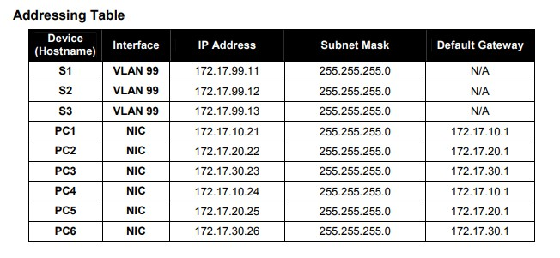

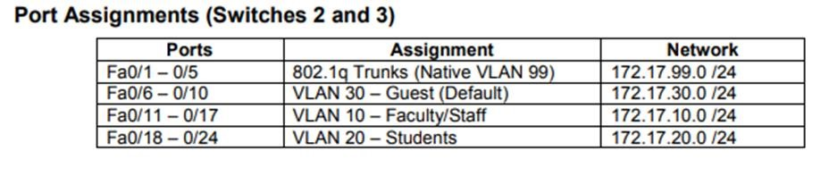

LAB TASK:
Cable a network that is similar to the one in the topology diagram.
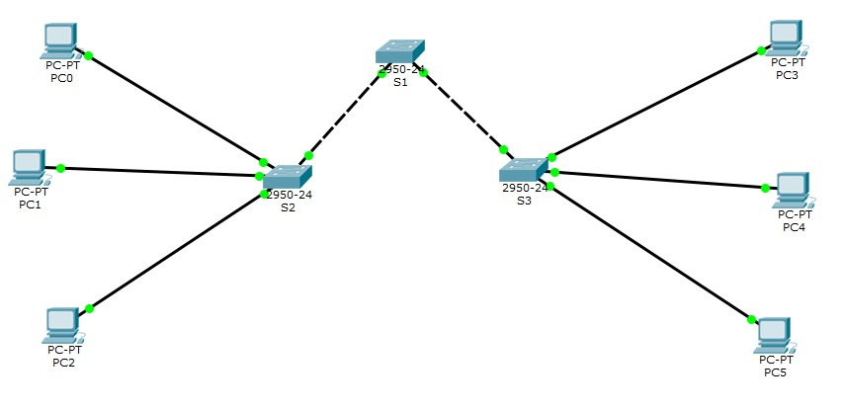

Configure the user ports in access mode. Refer to the topology diagram to determine which ports are connected to end-user devices.
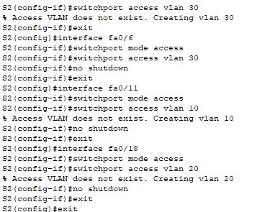

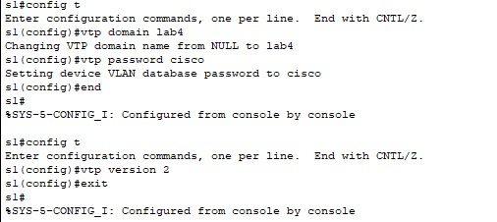
Configure VTP on the Switches

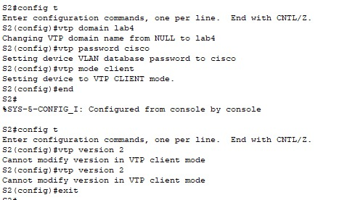

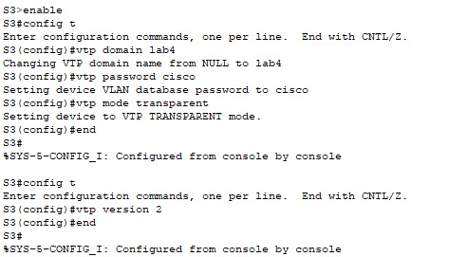

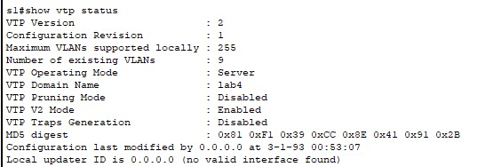
Check the current VTP settings on the three switches. S1#show vtp status

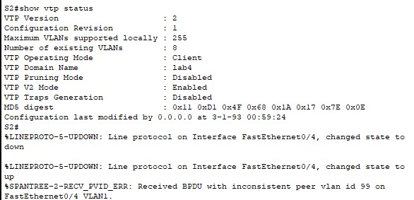

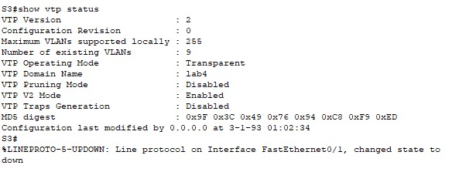

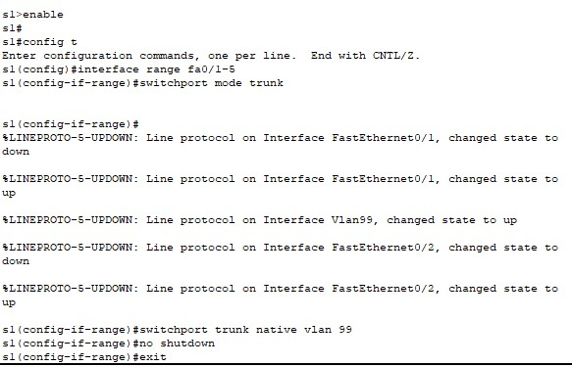
Configure trunking and the native VLAN for the trunking ports on all three switches.

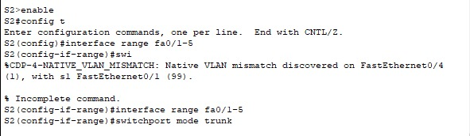

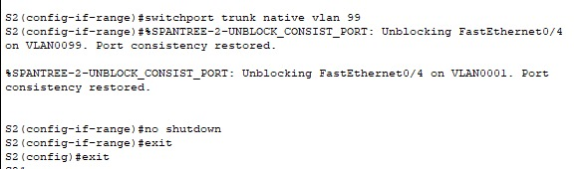

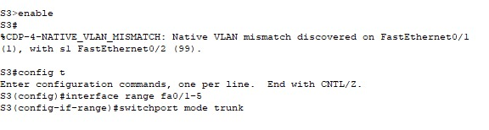

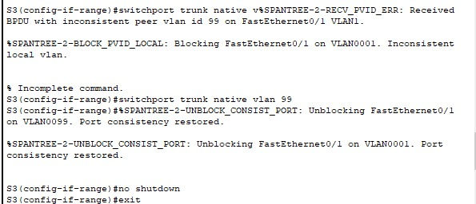

Configure VLANs on the VTP server
There are four additional VLANS required in this lab: VLAN 99 (management) VLAN 10 (faculty/staff) VLAN 20 (students)
VLAN 30 (guest)
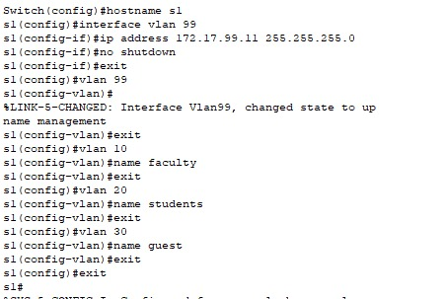

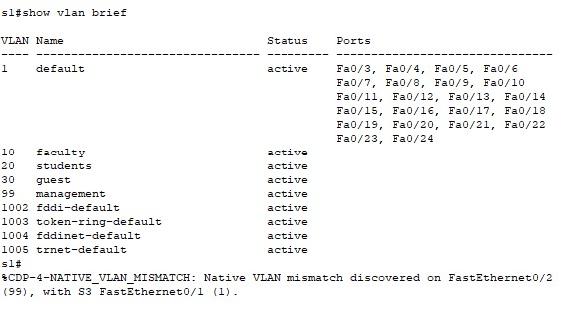
Verify that the VLANs have been created on S1 with the show vlan brief command.

Check if the VLANs created on S1 have been distributed to S2 and S3
S2#show vlan brief
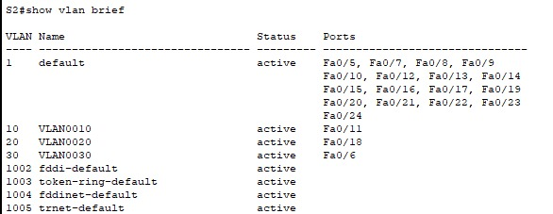

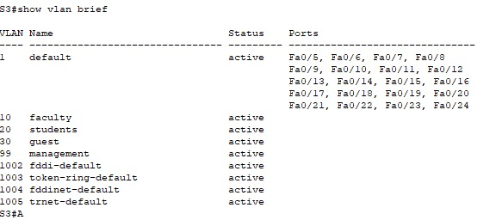

EXERCISES:

(1) Based on the topology, are the same VLANs configured on all switches?
Yes, the same VLANs (VLAN 99, VLAN 10, VLAN 20, and VLAN 30) are configured on all switches. This is because VTP propagates VLAN information from the VTP server (S1) to the client switches (S2).
(2) Explain why S2 and S3 have different VLAN configurations?
- S2 operates in VTP client mode, meaning it cannot create or modify VLANs and only receives VLAN information from the VTP server (S1).
- S3 operates in VTP transparent mode, so it does not participate in VTP updates and allows manual VLAN configuration locally.
(3) Why are you prevented from creating a new VLAN on S2 but not on S3?
- S2 is in VTP client mode, which prevents it from creating or modifying VLANs locally. It only accepts VLAN configurations propagated by the VTP server (S1).
- S3 is in VTP transparent mode, which allows VLAN creation and management locally without depending on the VTP server.
(4) What are the advantages of using VTP?
- Centralized VLAN Management: VLANs can be created and managed on a single VTP server, reducing administrative overhead.
- Automatic Propagation: VTP automatically distributes VLAN information to all client switches in the same domain.
- Consistency: Ensures uniform VLAN configuration across the network, reducing configuration errors.
- Scalability: Simplifies VLAN management in large networks by eliminating the need to manually configure VLANs on each switch.

Lab #12

Task 1) Filter out the TCP three-way handshaking packets out from your windump data and explain it as the same style as in the webpage

Steps to Filter TCP Handshake Packets in Windump:
- Run Windump: Start Windump to capture network traffic. If you are capturing live traffic, use:
windump -i <interface>
Replace <interface> with the appropriate interface name.
- Apply a Filter for Handshake Packets: Use the following filter to capture only the TCP three-way handshake packets (SYN, SYN-ACK, ACK):
windump "tcp[tcpflags] & (tcp-syn|tcp-ack) != 0"

- Capture Data:
  - The output will include only the SYN, SYN-ACK, and ACK packets.
  - Save the output to a file for further analysis:
  - windump "tcp[tcpflags] & (tcp-syn|tcp-ack) != 0" -w handshake.pcap

Explanation of the Captured Handshake Packets
After analyzing the output or opening the captured file in a tool like Wireshark, the following packets will be observed:
- SYN Packet:
  - Purpose: The client initiates a connection with the server.
  - Flags: SYN set, ACK not set.
  - Key Details:
    - Source IP: Client's IP.
    - Destination IP: Server's IP.
    - Sequence Number: Client's Initial Sequence Number (ISN).
    - Acknowledgment Number: 0.
Example Output:
12:01:00.001 Client_IP:50000 > Server_IP:80 SYN [seq=0] win=65535

- SYN-ACK Packet:
  - Purpose: The server responds to the client's SYN, agreeing to establish the connection.
  - Flags: SYN and ACK both set.
  - Key Details:
    - Source IP: Server's IP.
    - Destination IP: Client's IP.
    - Sequence Number: Server's ISN.
    - Acknowledgment Number: Client's ISN + 1.
Example Output:
12:01:00.003 Server_IP:80 > Client_IP:50000 SYN-ACK [seq=0 ack=1] win=65535

- ACK Packet:
  - Purpose: The client confirms the receipt of the server's SYN-ACK, completing the handshake.
  - Flags: ACK set, SYN not set.
  - Key Details:
    - Source IP: Client's IP.
    - Destination IP: Server's IP.
    - Sequence Number: Client's ISN + 1.
    - Acknowledgment Number: Server's ISN + 1.
Example Output:
12:01:00.005 Client_IP:50000 > Server_IP:80 ACK [seq=1 ack=1] win=65535

Final Output:
By filtering the packets using Windump and analyzing them, you observe the following:
- The client initiates the connection with a SYN packet.
- The server responds with a SYN-ACK packet.
- The client completes the handshake by sending an ACK packet.
Task 2) Draw the time sequence diagram for the TCP three way handshaking

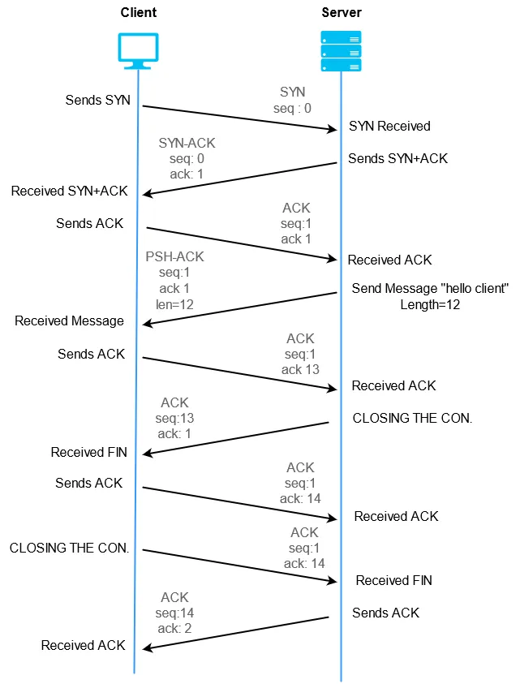

Lab # 06
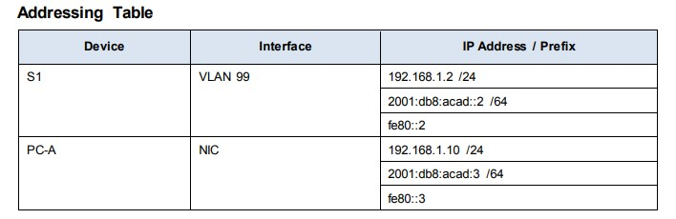

LAB TASK:

1. Enter privileged EXEC mode.
a. Click S1 and then the CLI tab. Press Enter.
b. Enter privileged EXEC mode by entering the enable command:
Open Configuration Window for S1
Switch> enable
Switch#
Notice that the prompt changed to reflect privileged EXEC mode.

2. Examine the current switch configuration.

Enter the show running-config command.
Switch# show running-config Answer the following questions:
a. How many Fast Ethernet interfaces does the switch have?
b. How many Gigabit Ethernet interfaces does the switch have?

3. Assign a name to a switch.
Switch# configure terminal
Switch(config)# hostname S1
S1(config)# exit

4. Secure access to the console line.
S1# configure terminal
Enter configuration commands, one per line. End with CNTL/Z.
S1(config)# line console 0
S1(config-line)# password letmein
S1(config-line)# login
S1(config-line)# exit
S1(config)# exit

5. Verify that console access is secured.
S1# exit
Switch con0 is now available Press RETURN to get started.
User Access Verification
Password:
S1>

6. Secure privileged mode access.
Set the enable password to c1$c0. This password protects access to privileged mode. Note: The 0 in c1$c0 is a zero, not a capital O. This password will not grade as correct until after you encrypt it in Step 8.
S1> enable
S1# configure terminal
S1(config)# enable password c1$c0
S1(config)# exit

7. Verify that privileged mode access is secure.
a. Enter the exit command again to log out of the switch.
b. Press <Enter> and you will now be asked for a password:

8. Configure an encrypted password to secure access to privileged mode.
The enable password should be replaced with the newer encrypted secret password using the enable secret command. Set the enable secret password to itsasecret.
S1# config t
S1(config)# enable secret itsasecret
S1(config)# exit

9. Configure a message of the day (MOTD) banner.
S1# config t
S1(config)# banner motd "This is a secure system. Authorized Access Only!" S1(config)# exit

10. Save and Verify Configuration Files to NVRAM
S1# copy running-config startup-config

11. Examine flash memory. Switch# show flash Switch# dir flash:
12. Configure an IP address on PC-A.
13. Verify and Test Network Connectivity
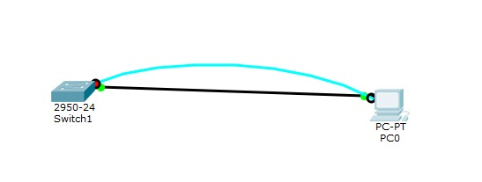

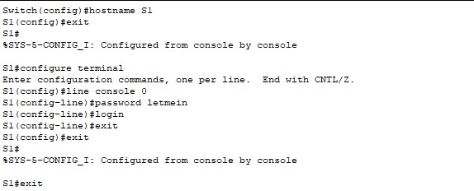

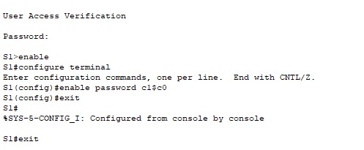

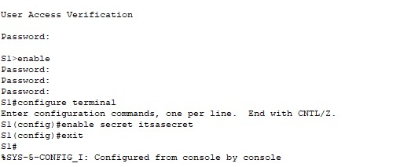

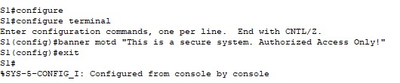

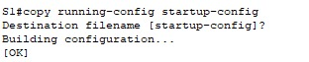

EXERCISES:
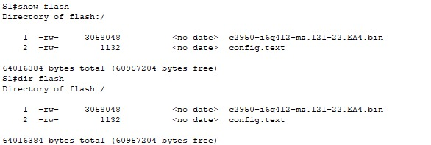

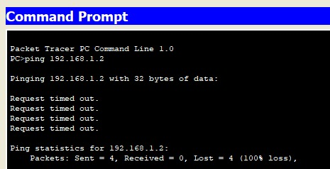
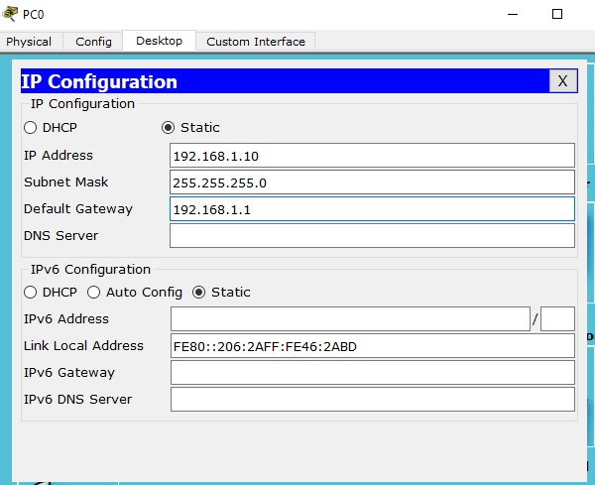

(1) How many FastEthernet interfaces does a 2960 switch have?
A Cisco Catalyst 2960 switch is a layer-2 switch that supports FastEthernet and GigabitEthernet interfaces.
- It typically has 24 or 48 FastEthernet (Fa) interfaces, depending on the model.
- These interfaces are used for connecting end devices such as computers, printers, and IP phones.

(2) What is the Cisco IOS version that the switch is running?
The Cisco Internetwork Operating System (IOS) is the software that runs on Cisco devices, providing networking features and CLI commands.
- The IOS version specifies the software release being used.
- The version can include the release number, maintenance release, and other details, such as 12.2(55)SE5.
- This is essential to know for compatibility and feature availability.

(3) What is the MAC address of the interface fa 0/6?
A MAC address (Media Access Control address) is a unique hardware identifier assigned to network interfaces.
- Each port on the switch, such as fa 0/6 (FastEthernet port 0/6), has its own MAC address.
- The MAC address is critical for layer-2 communication in the Ethernet network and helps switches forward frames to the correct destination.

(4) What is the filename of the Cisco IOS image?
The IOS image is the software file loaded into the switch to provide operating system functionality.
- It resides in the flash memory of the switch.
- The filename (e.g., c2960-lanbasek9-mz.122-55.SE5.bin) indicates details such as the switch model, feature set, and software version.
- Understanding the filename is useful when upgrading the IOS or troubleshooting.

Lab # 07
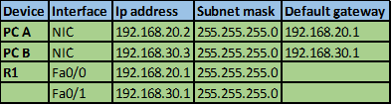

LAB TASK:
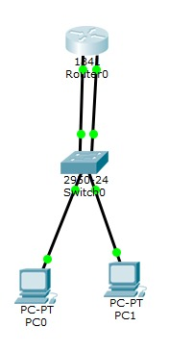
1.Design Vlan topology

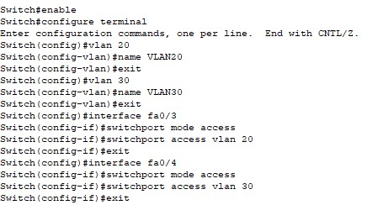
2.Configure IVR.

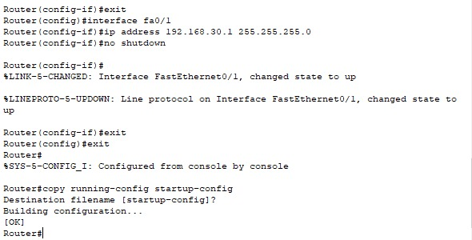
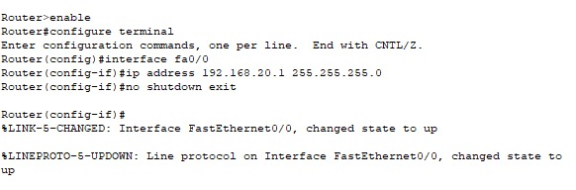
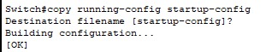

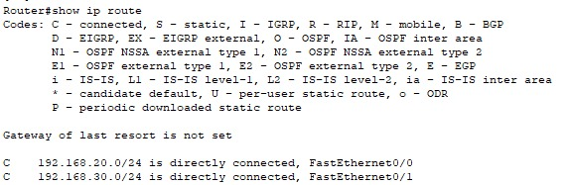
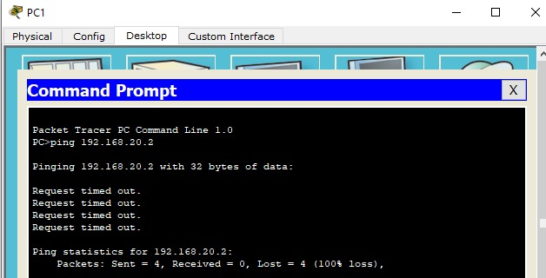
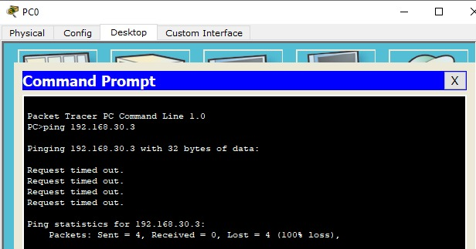
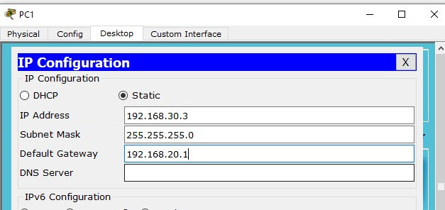
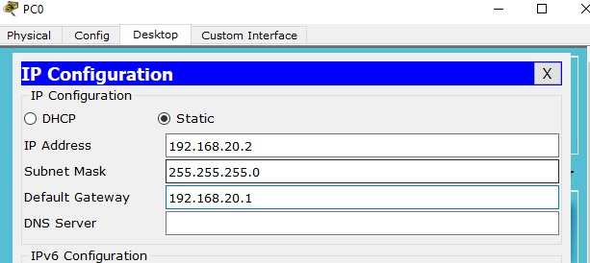
3.68"

